**Introduction:**

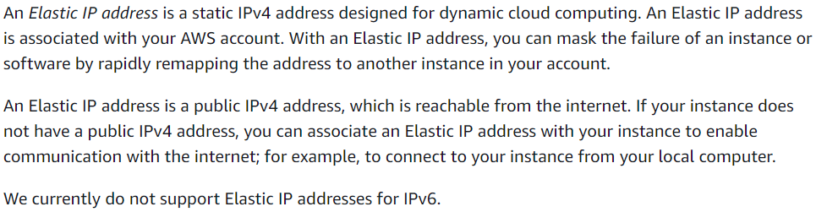

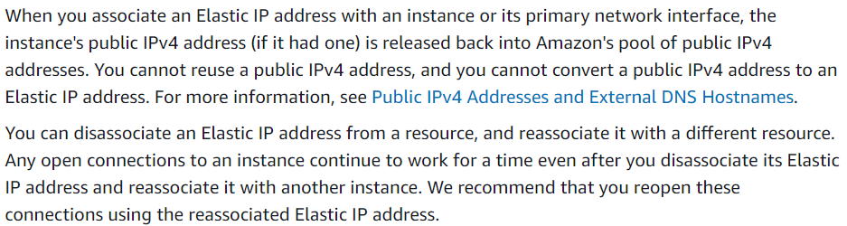

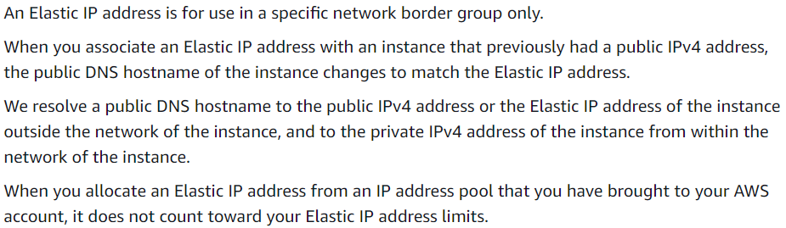

**Allocating the elastic IP:**

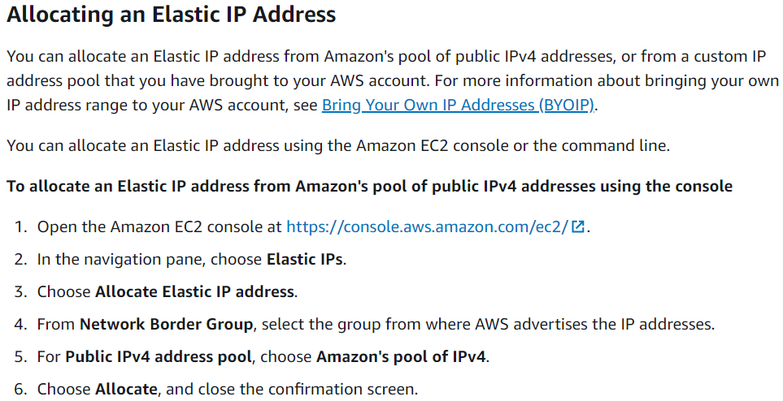

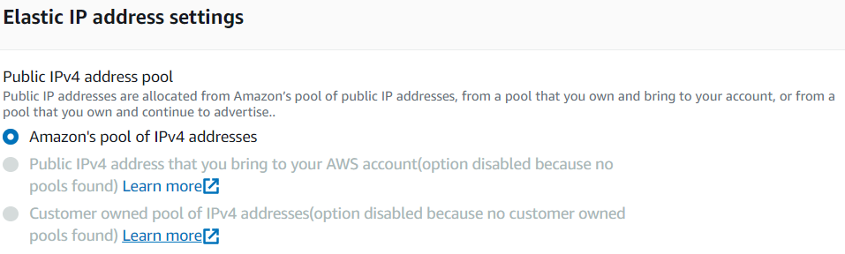

We can select the customer owned pools or the own public IPs if we want.

**Tagging an elastic IP:**

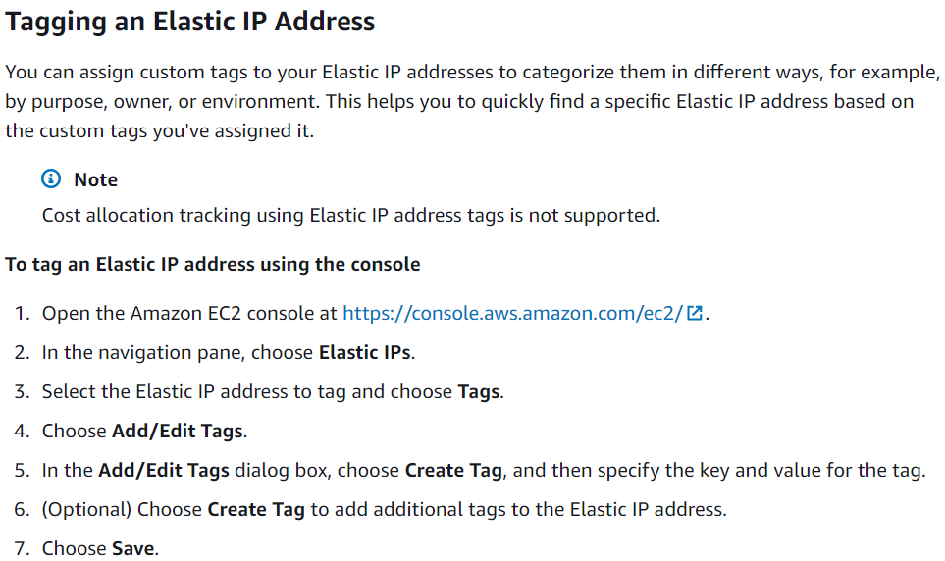

**Associate an elastic IP to an instance:**

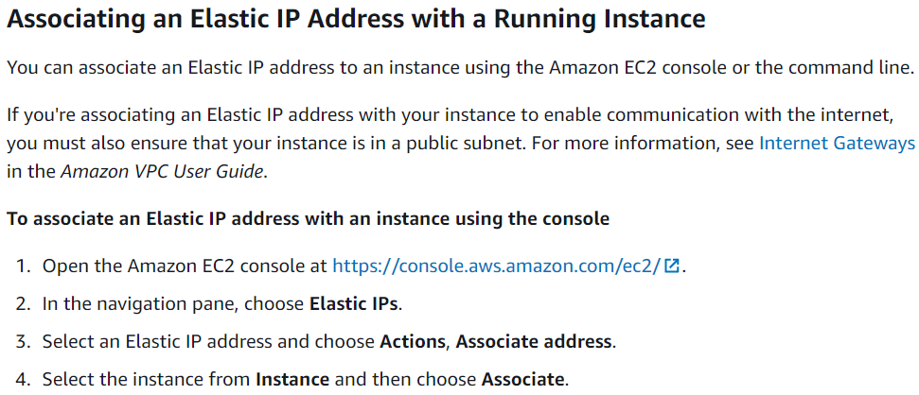

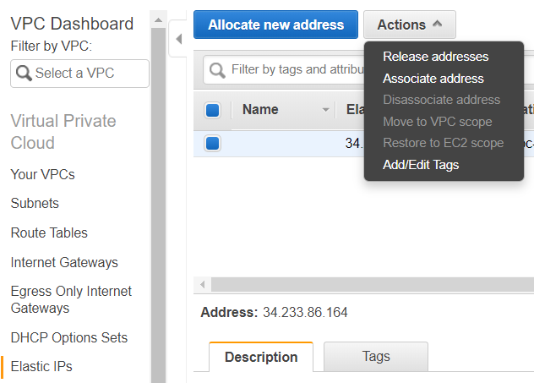

**We can associate elastic IP to an instance or network interface**

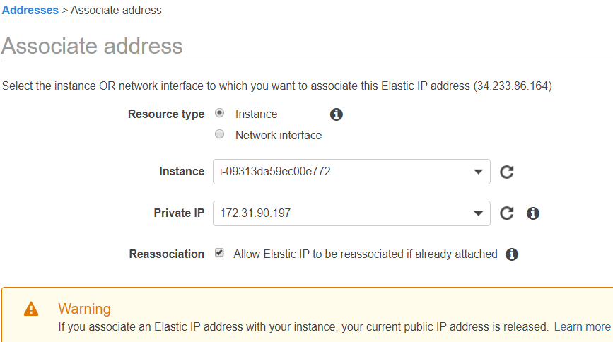

**You can reassociate the elastic IP to an instance even the IP was already associated to any other machine**

**For that, we need to check the reassociated option as above, otherwise we can’t assign the IP to another machine as below**

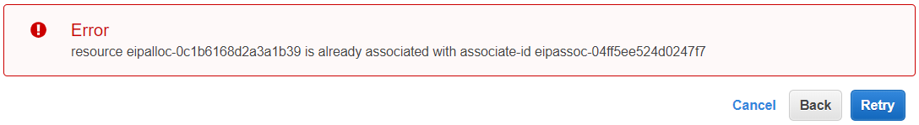

Once we associate the elastic IP to an instance, then the public IP of the instance will be removed

**Deassociate an elastic IP:**

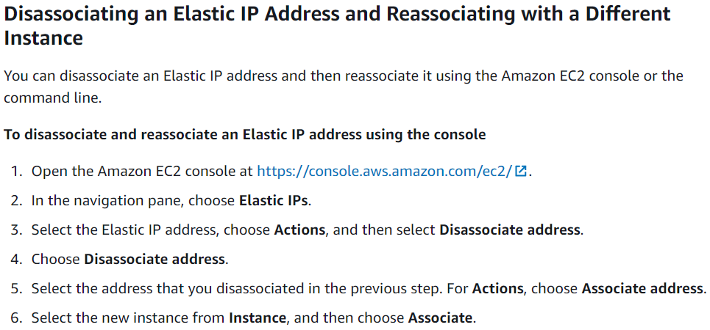

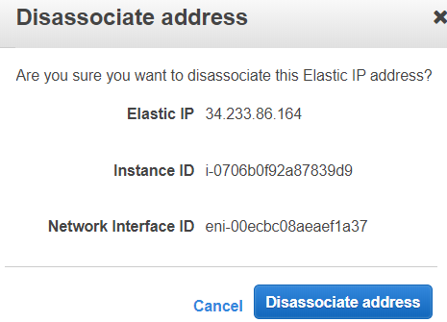

**Release an elastic IP:**

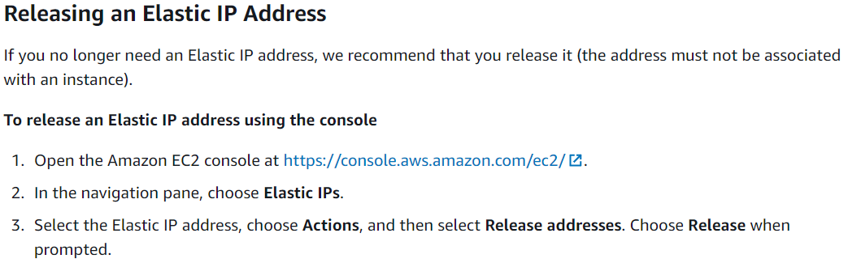

**Recover an elastic IP:**

